

**Student ID:** 23123

**Course code:** INSY423

**Course** **name**: Web Technology and Internet

topic: RWANDAMILITARY management System

web TECHNOLOGY AND internet final exam project

December 9, 2023

**Munyeshyaka Donatien**

**AUCA: ADVENTIST university of central africa**

shyakadon@gmail.com

Table of Contents

Rwanda Military management system 3

1. Introduction 3

1.2 Ambition 3

1.3 Scope of the system 4

1.4. Entity relationship of the system 5

1.5 Design organization of the system 6

1.6 Screenshots of Rwanda Military Management system 7

*Figure 1: Home Screen* 7

*Figure 2: Admin Signup page* 8

*Figure 3: Admin Login page* 9

*Figure 4: Admin Signup page when successfully* 10

*Figure 6: Admin when is approving any soldier* 12

*Figure 7: Admin views the all Soldiers Registered* 13

*Figure 8: Admin’s updating Soldier* 14

*Figure 9: Admin’s searching any Soldier* 15

*Figure 10: Admin’s searching Unknown Soldier Id* 16

*Figure 11: Result after Admin’s searching Unknown Soldier Id* 17

*Figure 12: Soldiers PDF downloaded format* 18

18

*Figure 13: User Signup page or Create Account* 19

*Figure 15: User Login page* 21

*Figure 16: User Logged in page* 22

*Figure 17: User’s registering* 23

*Figure 18: User received an email from the Admin* 24

*Figure 19: Any hesitate connect with us for* 25

1.7 Deployment link of Rwanda Military Management system 26

*1.7.1 Link****=>*** 26

1.8 Conclusion 26

# Rwanda Military management system

## 1. Introduction

An Army management system is a software solution designed to streamline and automate the process of registering individuals who wish to join the army or military service. It serves a centralized platform that facilitates the efficient management of the registration process, from initial application to enrollment

## 1.2 Ambition

Efficiency and Speed: The system seeks to expedite the registration process by minimizing paperwork, automating data collection, and eliminating manual errors. It aims to ensure that applicants can complete the registration process as quickly and smoothly as possible.

Accuracy and Data Integrity: The ambition is to maintain accurate and reliable records of applicant information. The system aims to validate and verify the authenticity of documents and qualifications provided by applicants to ensure the integrity of the registration process.

Standardization and Consistency: The ambition is to establish standardized procedures and criteria for registration across different regions or branches of the army. This ensures that all applicants are evaluated and processed based on the same set of requirements, promoting fairness and equal opportunities.

Security and Confidentiality: The system aspires to uphold the security and confidentiality of applicant data. It aims to implement robust security measures to protect personal and sensitive information, ensuring that unauthorized access or breaches are prevented.

# 1.3 Scope of the system

The Army management System ensures the efficient and standardized handling of applicant information across different regions or branches of the army.

**2.** It prioritizes accuracy and data integrity to maintain reliable records of applicant **3.** Details and validate the authenticity of submitted documents.

**4.** The system aims to enhance the overall applicant experience by simplifying the registration process, providing clear instructions, and offering support throughout the various stages of registration.

**5.** Security and confidentiality of applicant data are paramount, with robust

Measures in place to protect personal and sensitive information from unauthorized access or breaches

**6.** The ambition of the Army Registration System is to contribute to the effectiveness of military recruitment efforts by efficiently registering and enlisting qualified individuals for appropriate army roles.

# 1.4. Entity relationship of the system

Army

Signup

Contact us

Create account

Suggestion

On the system

1 n 1 n

1,n

1

# 1.5 Design organization of the system

Welcome page

login

signup

Admin page

User page

home

registration

suggestion

comment

logout

home

View

search

generate report

message

Create account

logout

# 1.6 **Screenshots of Rwanda Military Management system**

## *Figure 1: Home Screen*

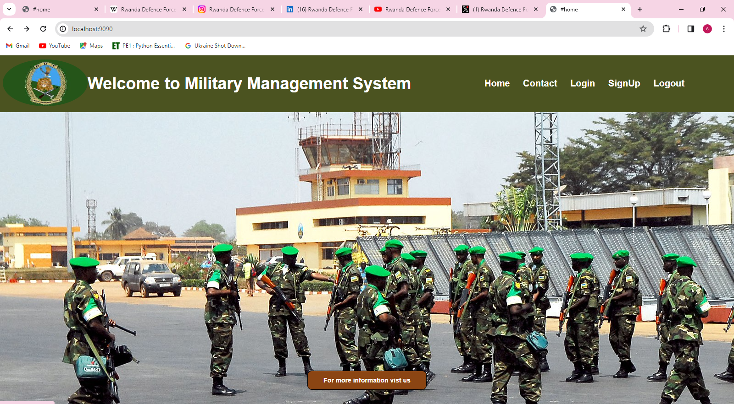

## *Figure 2: Admin Signup page*

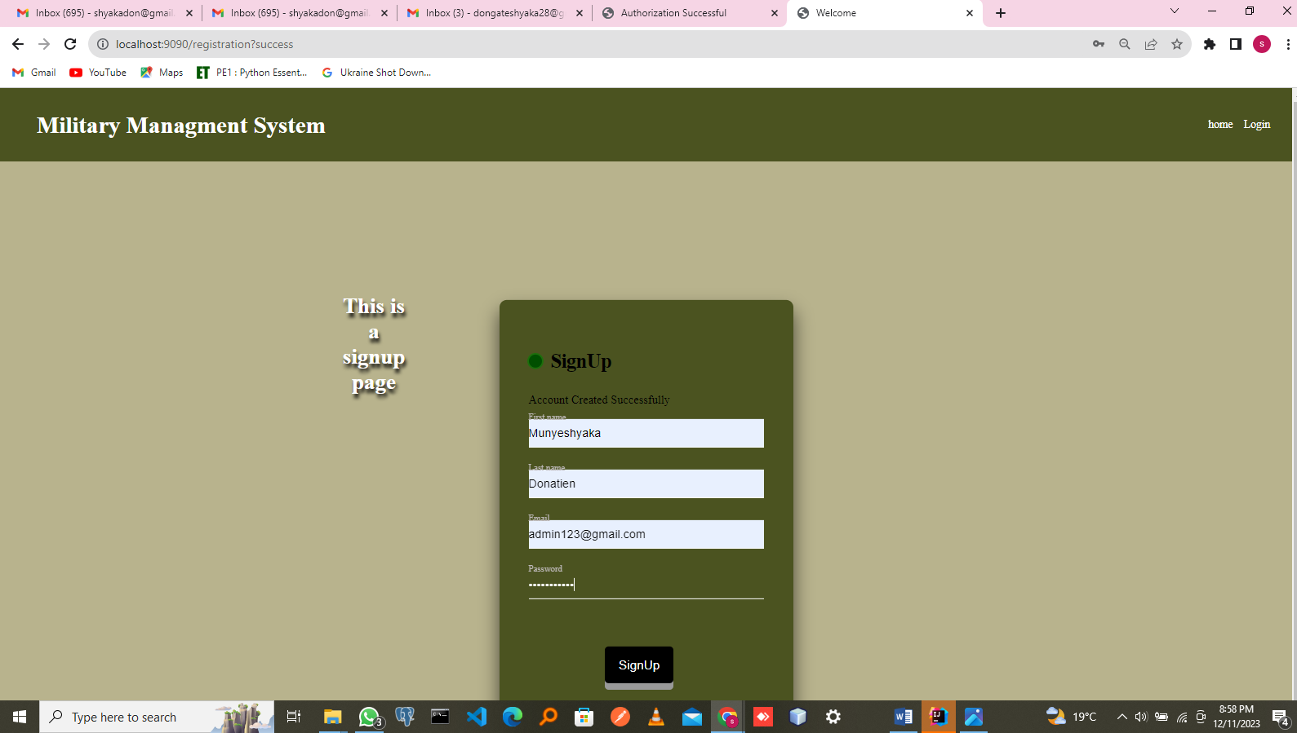

## *Figure 3: Admin Login page*

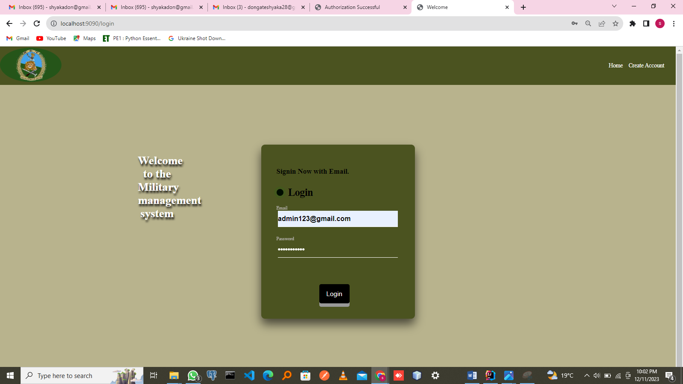

## *Figure 4: Admin Signup page when successfully*

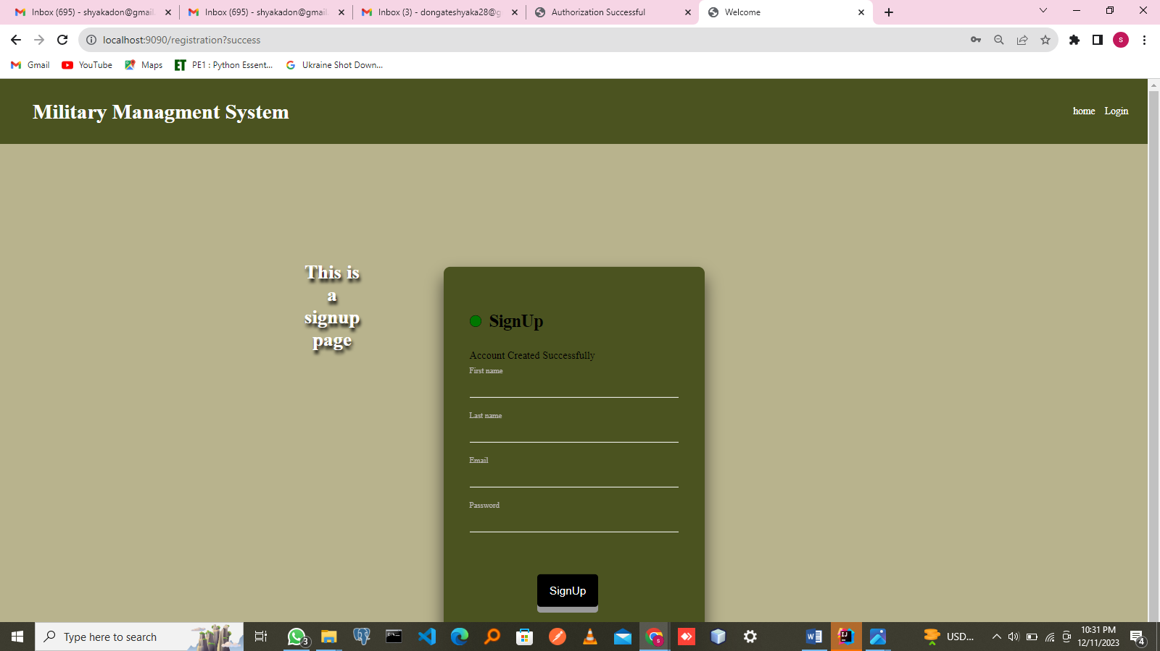

*Figure 5: Admin Portal*

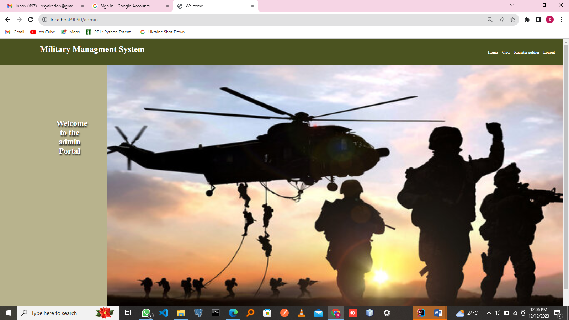

## *Figure 6: Admin when is approving any soldier*

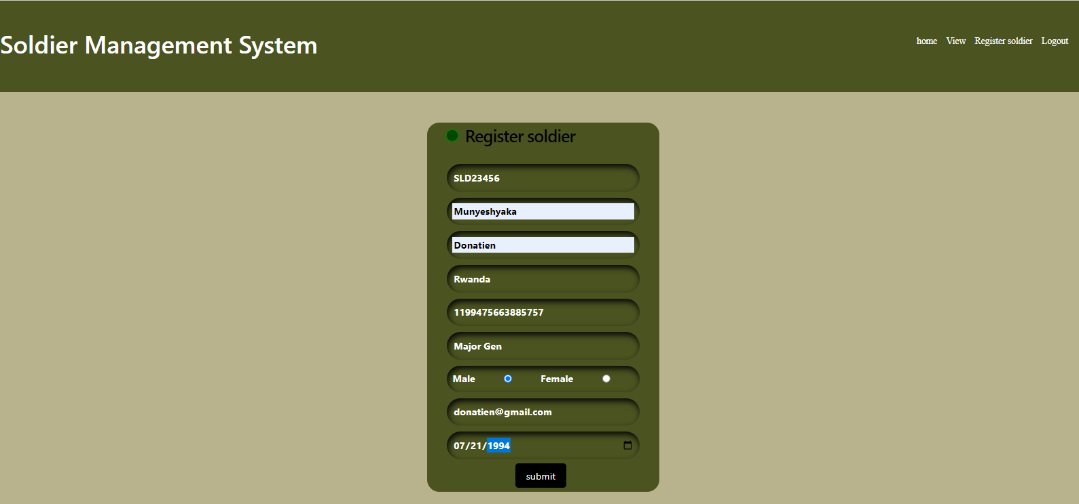

## *Figure 7: Admin views the all Soldiers Registered*

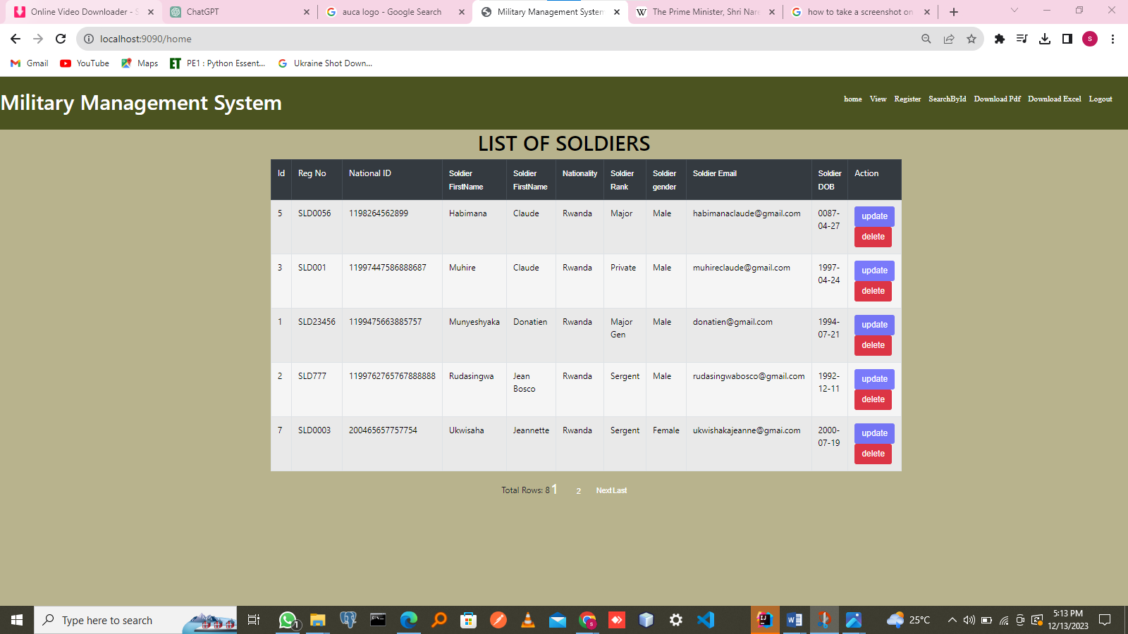

## *Figure 8: Admin’s updating Soldier*

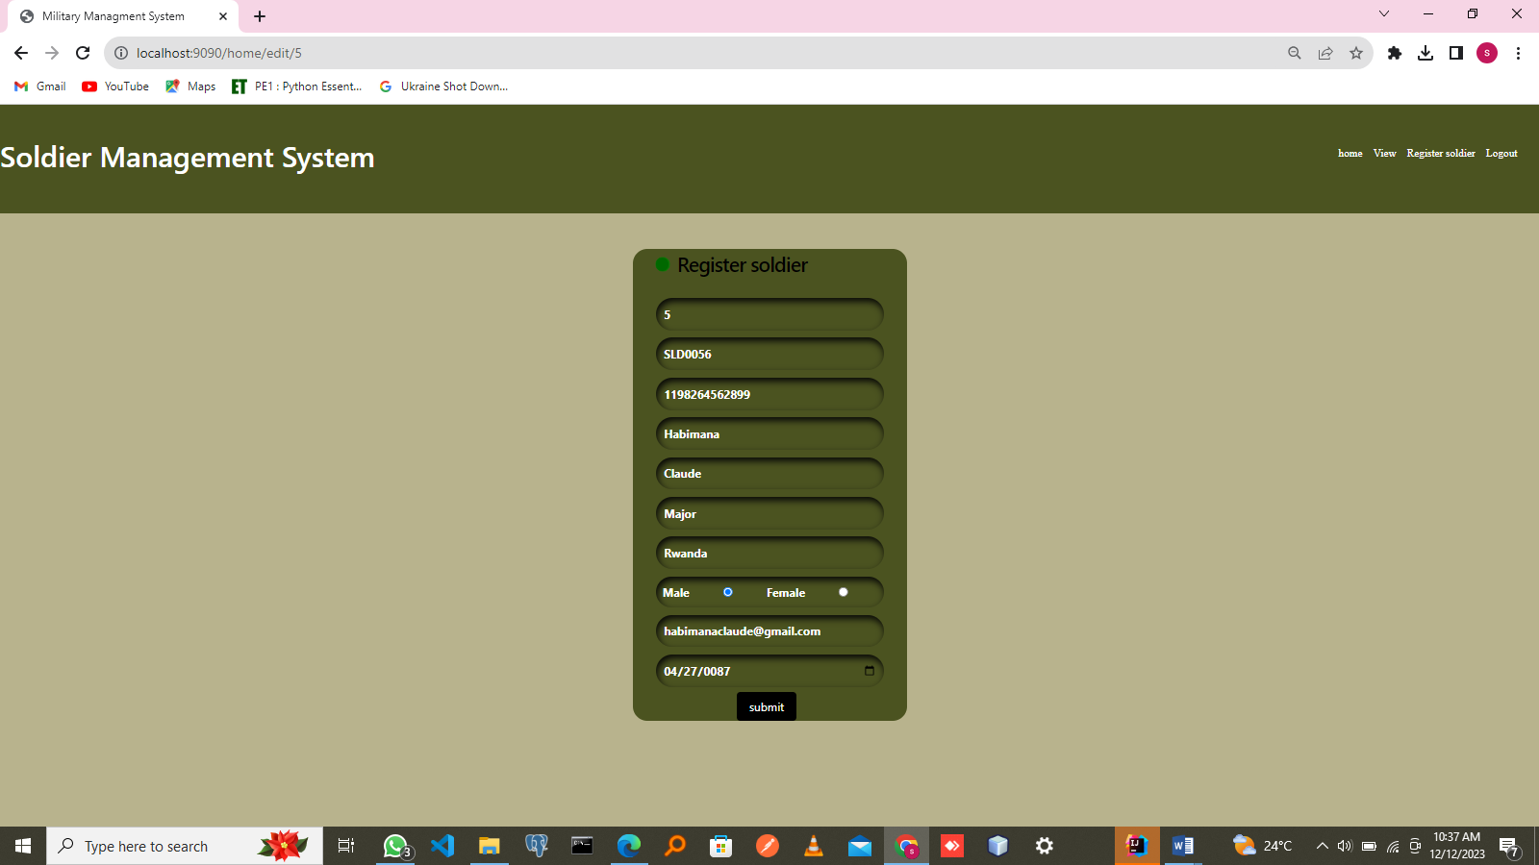

## *Figure 9: Admin’s searching any Soldier*

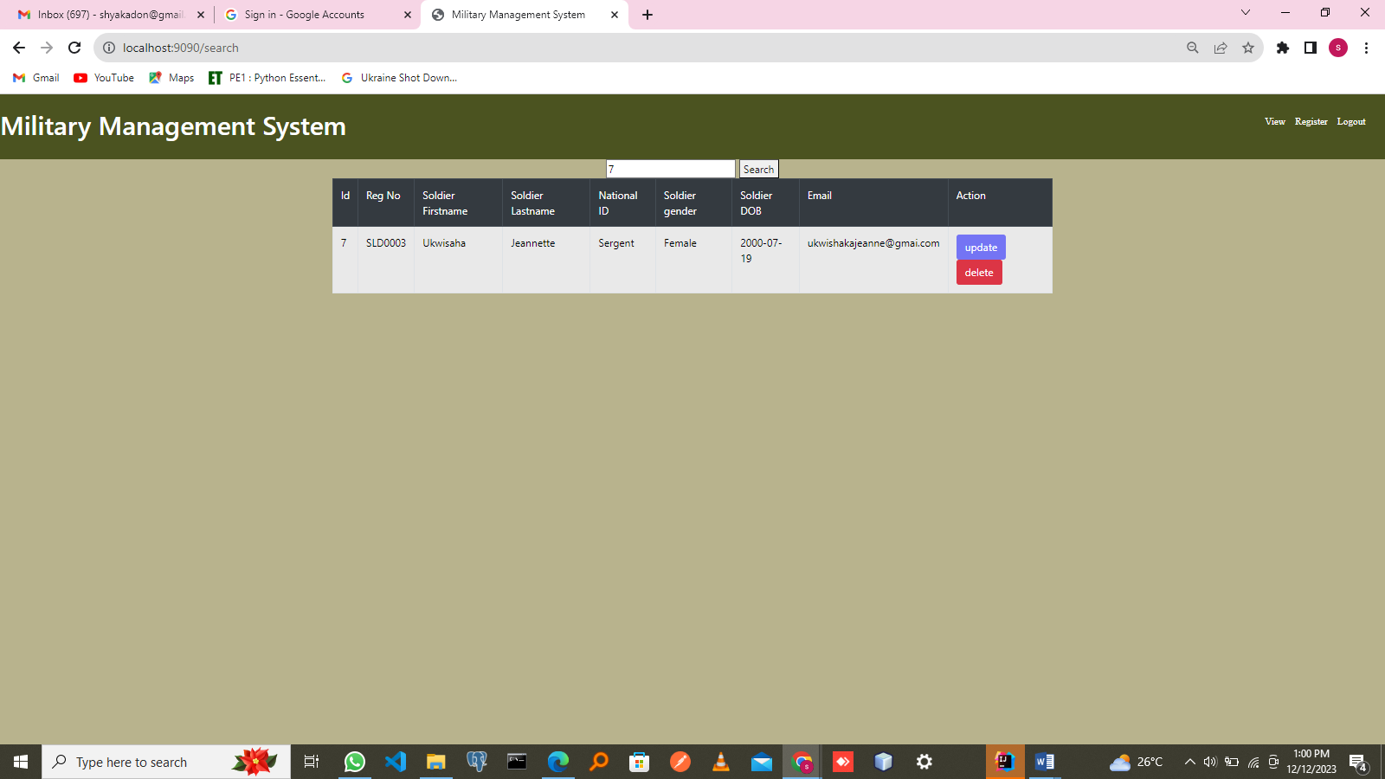

## *Figure 10: Admin’s searching Unknown Soldier Id*

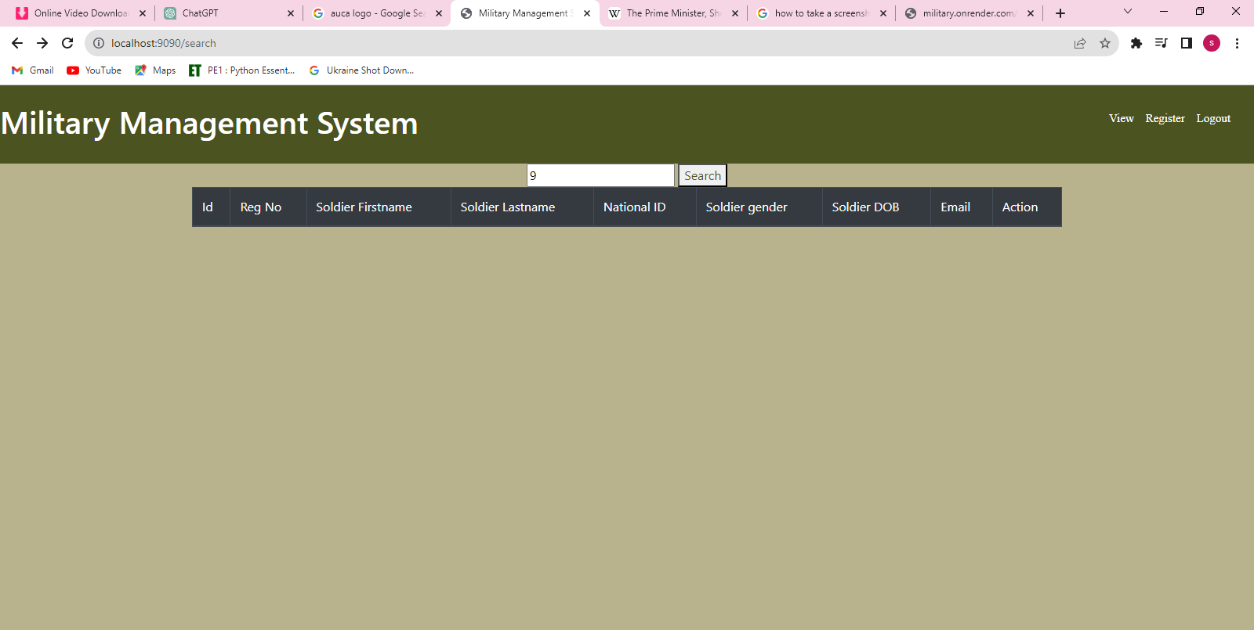

## *Figure 11: Result after Admin’s searching Unknown Soldier Id*

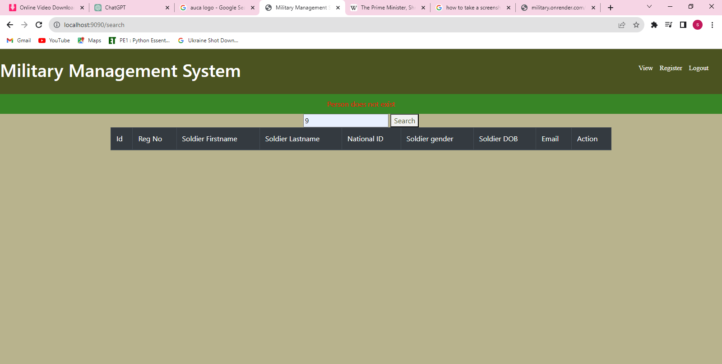

## *Figure 12: Soldiers PDF downloaded format*

## C:\Users\HP\Desktop\AllSave\soldierPage\pdfdownload.PNG

## *Figure 13: User Signup page or Create Account*

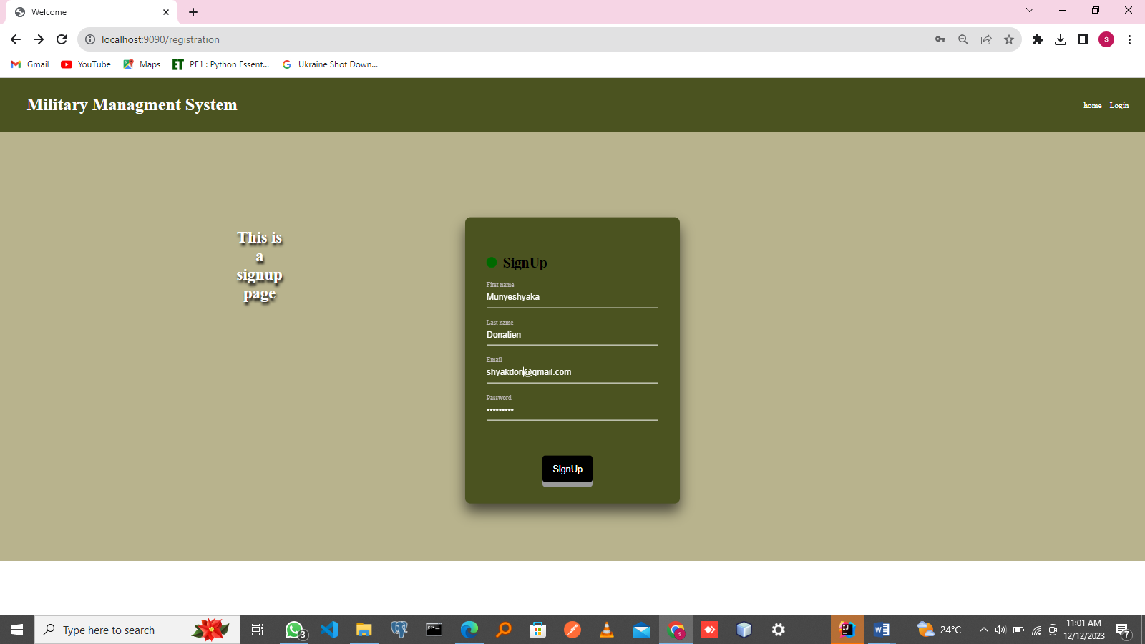

*Figure 14: User create account successfully*



## *Figure 15: User Login page*



## *Figure 16: User Logged in page*

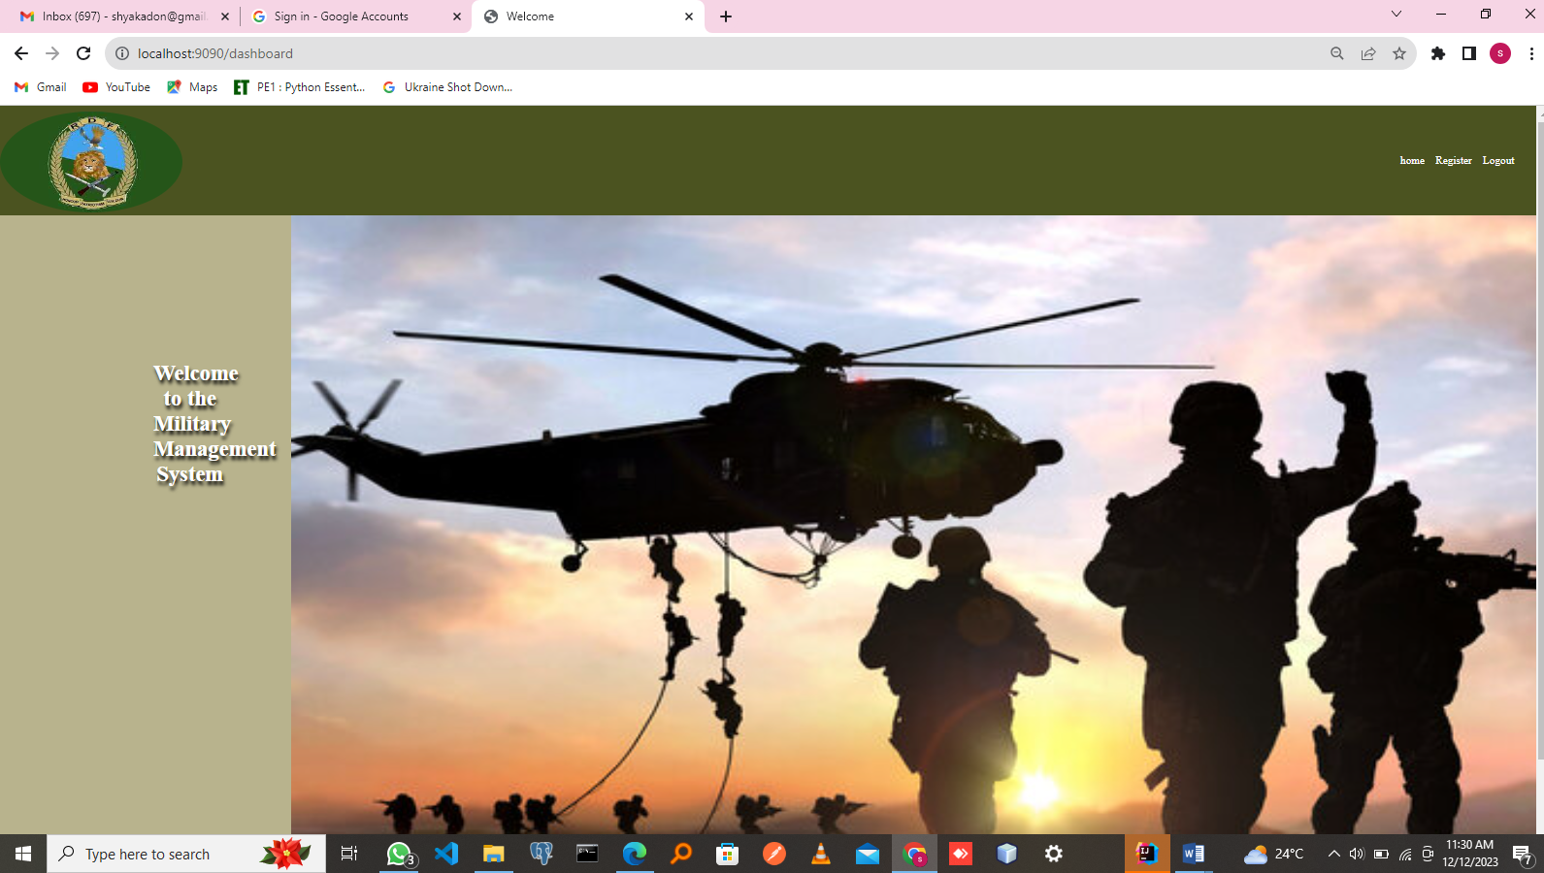

## *Figure 17: User’s registering*

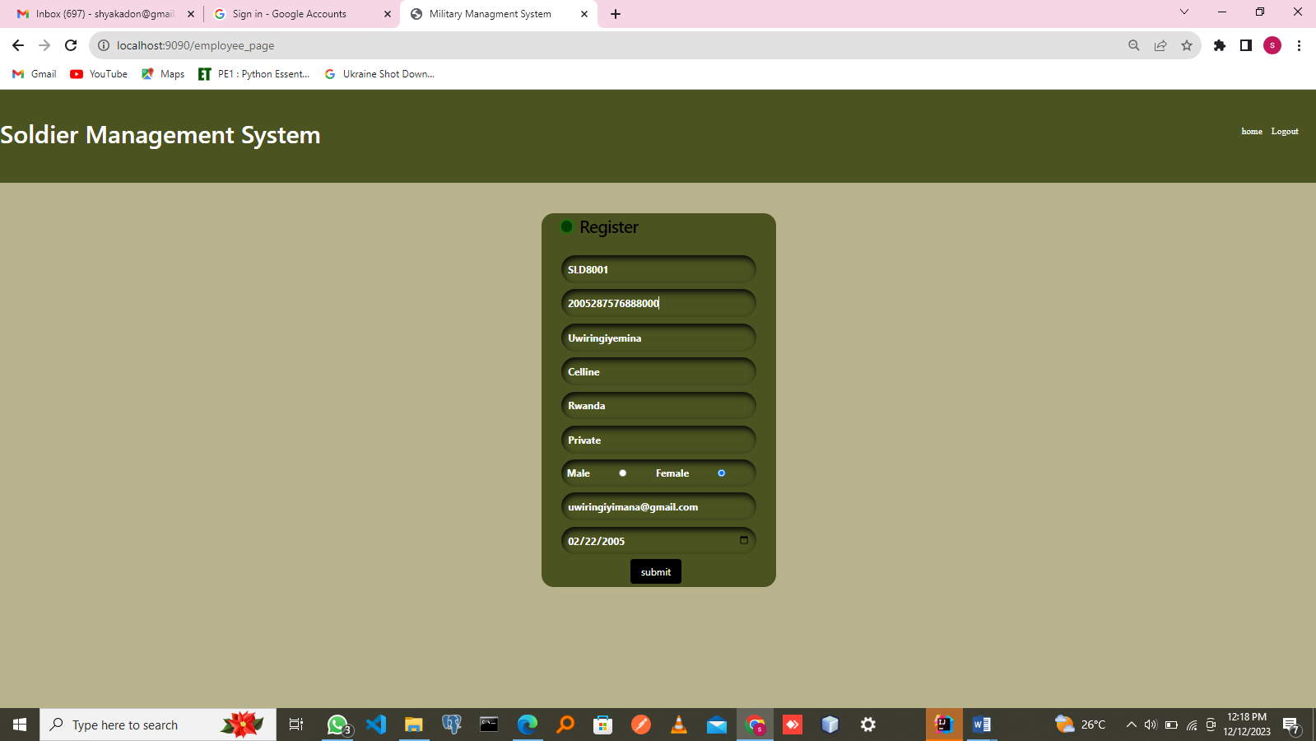

## *Figure 18: User received an email from the Admin*

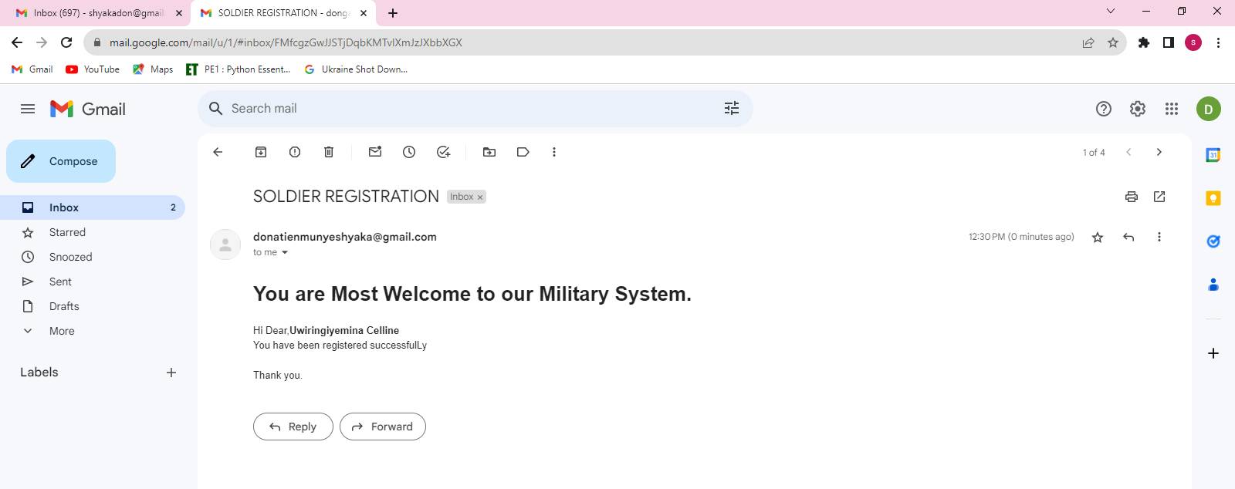

## *Figure 19: Any hesitate connect with us for*

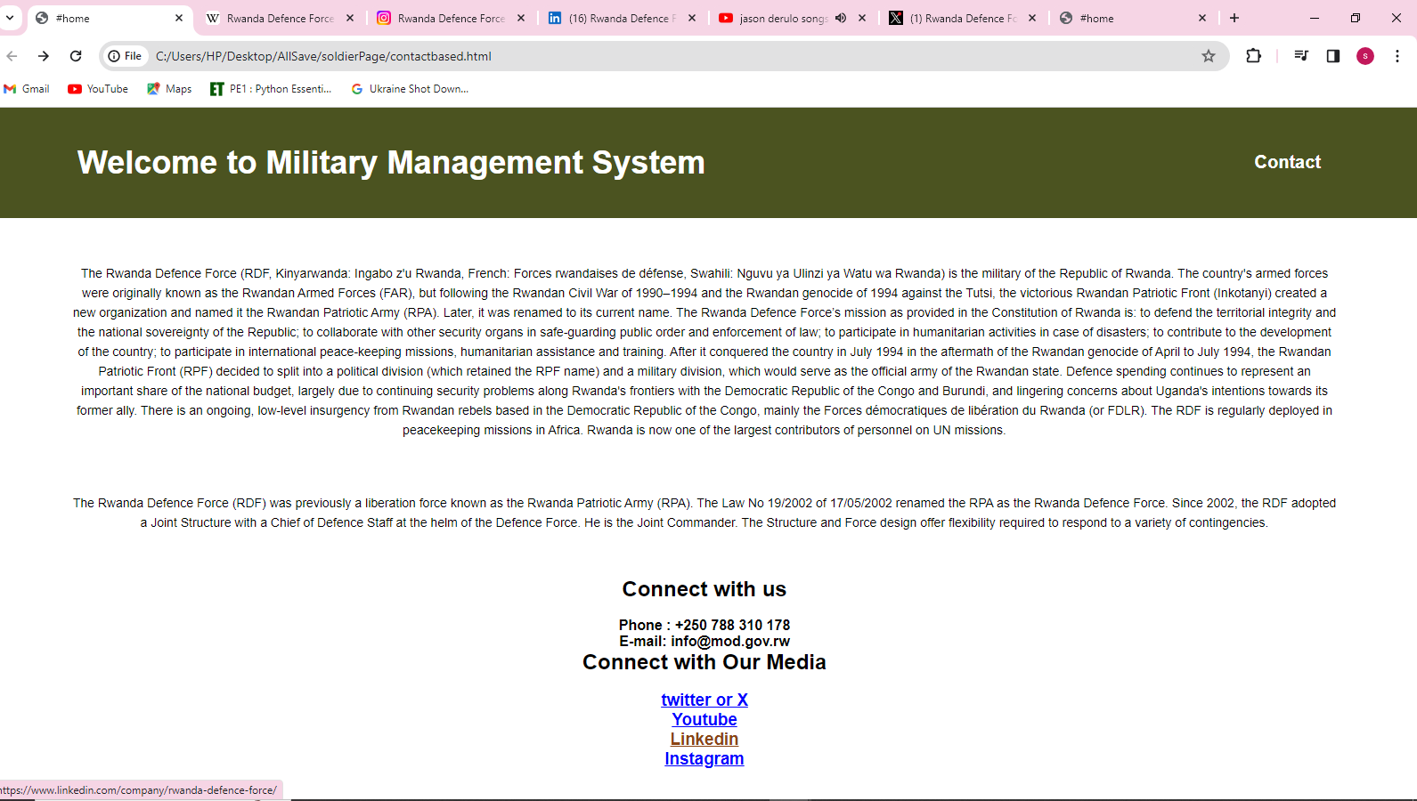

# 1.7 Deployment link **of Rwanda Military Management system**

*1.7.1 Link****=>*** https://final-project-of-donatien.onrender.com

# 1.8 Conclusion

The Rwanda army's effective management requires a holistic approach. Emphasizing leadership training, modernizing equipment, and fostering a culture of accountability are crucial. Implementing transparent communication channels and empowering soldiers through education and skill development would enhance operational efficiency. Strengthening civil-military relations and prioritizing human rights education within the military framework are vital for sustainable growth. Additionally, fostering regional partnerships for strategic cooperation and fostering a sense of national identity among troops are key factors. Ultimately, balancing modernization with ethical conduct and fostering a resilient, skilled force is paramount for Rwanda's army system.